1. **When we have 4 tiers, we do not call it 4-tier architecture we call it N-Tier Architecture.**
2. **Web Server**:
   1. It is mandatory for all the web applications otherwise web applications will not work.
   2. Web Server contains presentation layer.
3. Let us see the communication among these layers.
   1. Suppose you open browser and make a request to [www.facebook.com](http://www.facebook.com)
   2. The request goes to **Web Server**.
   3. Web Server has intelligence given by Developers using some programming languages.
   4. A first request goes to Web Server then to App Server then to DB Server in case of login transaction.  
      This complete request/response flow is called Transaction in PT Term.
   5. Web Server has static content like logo, background etc.
   6. The dynamic content comes from App Server.
4. **Why is it called N-Tier Architecture not 4-Tier Architecture**?
   1. As in case of 4 tiers, each layer is on its own server (Web Server, App Server, DB Server), then we have opportunity to scale out app server and DB server which in that case will raise more tiers.  
      That is why it is called N-Tier architecture not 4-Tier Architecture.
5. **Load Balancer**:
6. **Real Life Example**:  
   

**Load Balancer in System Example**:  
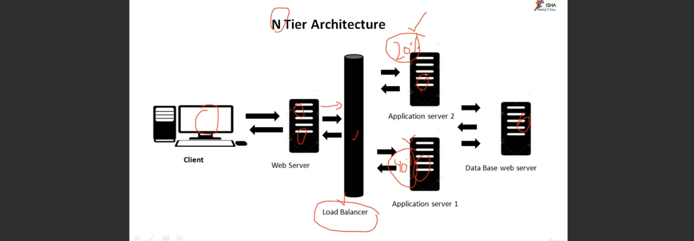  
Some Developers write their own load balancers through code in case of two App Servers.

1. **PT Terms**:
   1. **Transaction**: One request and response flow is called Transaction.
   2. **Response Time**: The total time taken for a request/response transaction.  
      We call it **Response Time or Transaction Response Time** or **End to End Transaction Response Time**.
   3. **Scale Out**: To add a new server in parallel.
   4. **Scale Up**: To increase existing server’s resources.